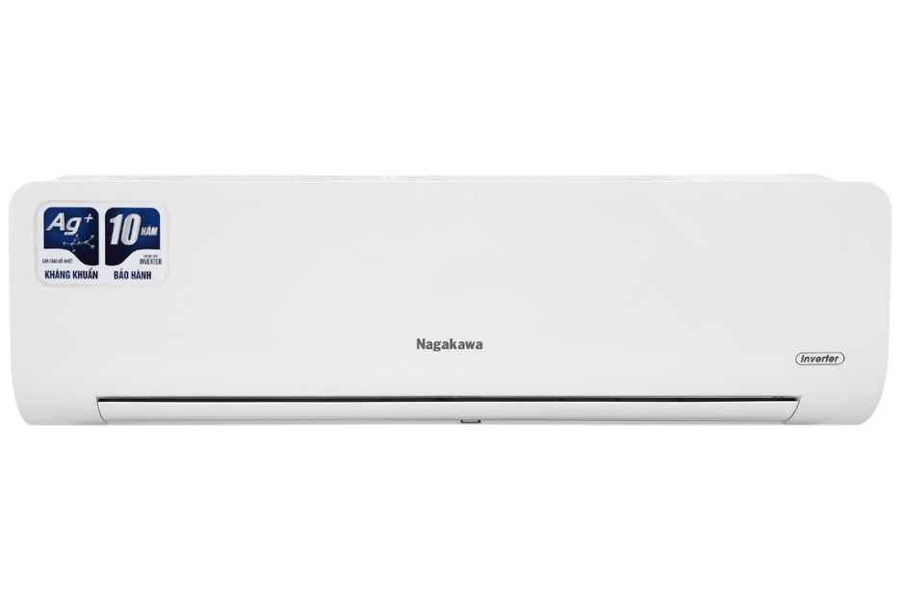

**8,190,000 VND**

~~9,390,000 VND~~(-12%)

**Technical specifications of Nagakawa Inverter 1 HP NIS-C09R2H10 air conditioner**

* Machine Type:

1 way (cooling only) With Inverter

* Cooling capacity:

1 HP - 9,000 BTU

* Effective cooling range:

Under 15m² (from 30 to 45m³)

* Dust filter, antibacterial, deodorant:

5-layer integrated air cleaning system

* Power saving technology:

EconomyInverter

* Rapid cooling:

Super

* Utilities:

Smart operating mode Smart Sleep operating mode Dehumidifying function Self-cleaning function 4D air swing function iFeel temperature sensor Blue Fin radiator with antibacterial Ag+ ion coating Super quiet operation Quiet Turn-on timer Turn off the machine The temperature display screen on the indoor unit Remote has an LED light. Automatically restarts when power is restored

* Power consumption:

0.81 kW/h 5 stars (Energy efficiency 4.54)

* Cooler:

Length 82.2 cm - Height 25.5 cm - Thickness 20.8 cm - Weight 7.5 kg

* Outdoor:

Length 74 cm - Height 48.2 cm - Thickness 25.5 cm - Weight 20.5 kg

Introducing the company 

- Vietnamese brand.  
- Established in 2002.  
- Diverse business products: air conditioners, dishwashers, induction cookers,.... with product prices easily accessible to consumers.  
- Achieved many outstanding achievements: Top 100 best products for families and children (2023), golden brand for Vietnamese health (2019),...

**Auto Clean self-cleaning function effectively kills bacteria and deodorizes**

[Nagakawa Inverter 1 HP NIS-C09R2H10 air conditioner](https://www.dienmayxanh.com/may-lanh/nagakawa-nis-c09r2h10)  has a self-cleaning function that contributes to creating a fresh atmosphere by removing bacteria and mold up to 99.9% effectively and drying water condensed on the radiator. Eliminate the breeding environment for pathogens.

[The self-cleaning function](https://www.dienmayxanh.com/kinh-nghiem-hay/tu-lam-sach-tren-may-lanh-la-gi-1070640)  also helps the machine operate at optimal capacity and increases the life of the air conditioner, saving on cleaning costs for the family.

**Purify the air, protect your health with a 5-layer air cleaning system**

The air cleaning system on  [Nagakawa air conditioners](https://www.dienmayxanh.com/may-lanh-nagakawa)  with a 5-layer filter membrane has the effect of cleaning the air and removing agents that negatively affect human health such as bacteria, dirt, mold, etc. .optimally.

**Inverter technology super saves electricity**

Inverter technology not only helps the air conditioner operate smoothly and durably, but also helps the room temperature always maintain a stable level, thereby saving electricity and significantly reducing monthly electricity costs for your family.

In addition, the Economy energy saving function also contributes to optimal energy savings when activated.

**Instant and fast cooling with Super mode**

With Super mode, the air conditioner will increase performance as soon as this mode is activated to achieve a fast cooling speed to instantly cool the atmosphere, so you don't need to wait too long to cool down. the room is cold enough.

**Smart temperature sensor on I Feel remote**

Nagakawa air conditioner's I Feel smart temperature sensor is integrated on the remote.

This sensor will transmit a signal to the indoor unit about the temperature it measures in the surrounding environment where the remote is located. Therefore, you just need to place the remote next to your body to enjoy the cool air flow as desired.

**The BlueFin green-plated heat exchanger prevents oxidation and protects the air conditioner**

The heat exchanger of this Nagakawa air conditioner is covered with a blue BlueFin layer that prevents corrosion by weather conditions, increasing resistance and durable use.

**Luxurious design, 1 HP capacity, suitable for areas under 15 m2**

Nagakawa Inverter NIS-C09R2H10 air conditioner possesses a simple but no less luxurious design thanks to its prominent white color tone in every interior space.

If your room has an area of ​​less than 15 m2,  this [Nagakawa 1 HP air conditioner](https://www.dienmayxanh.com/may-lanh-nagakawa?g=1-hp)  will be an extremely ideal choice.

**Easier control and monitoring with LED temperature display**

With a gentle LED display on the indoor unit, at night you no longer need to use a flashlight to check the temperature on the remote, making it easy to monitor and adjust the temperature of the machine.

**Increase cooling performance with 4D air swing mode**

4D air swing mode allows the air flap to swing the air vertically (up/down) and horizontally (left/right) with just one key on the remote. This air swing mode helps the cold air spread evenly to every part of the room.

**The room is airy and dry with dehumidification mode**

[The dehumidifying mode](https://www.dienmayxanh.com/kinh-nghiem-hay/cac-che-do-thuong-thay-tren-may-lanh-795107#hmenuid6)  is especially suitable for rainy and windy days with high air humidity, helping to reduce moisture in the air, returning the room to a dry, pleasant space.

Note: Dehumidifying mode only helps reduce humidity in the air and does not have a cooling effect.

**Convenient auto-restart function when power is restored**

The air conditioner can automatically remember operating settings when the power is suddenly interrupted with the function of  [automatically restarting when power is restored](https://www.dienmayxanh.com/kinh-nghiem-hay/che-do-hen-gio-va-tu-khoi-dong-khi-co-dien-lai-co-588231#hmenuid3) .

When the power is restored,  [the air conditioner](https://www.dienmayxanh.com/may-lanh)  will operate automatically according to the previously memorized parameters. Therefore, you do not need to spend a lot of time resetting the parameters for the air conditioner to operate.

In general, the Nagakawa Inverter 1 HP NIS-C09R2H10 air conditioner is suitable for room areas under 15 m2. Air conditioners provide energy saving efficiency along with instant cooling ability, promising to bring great experiences when used.